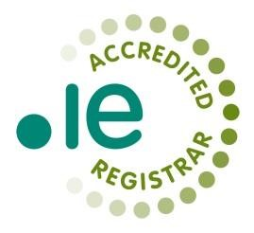
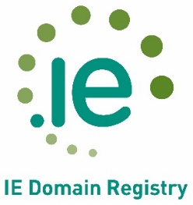



IE DOMAIN REGISTRY CLG

VOLUME GROWTH REBATE SCHEME (vgRS) 2019

volume growth Rebate Scheme for 2019

- All .ie Accredited Registrars are entitled to participate in the programme (opt-in will be required).
- The calculation will baselined at 1 January 2019.
- Rebate will be paid on a per domain basis.
- Rebate will be based on “net growth” in the period, where “net growth” is defined as the increase in billable domains in the period. (This will be new registrations less deleted domains, plus net transfers in/out in the period).
- Rebate will be calculated as €x times the “net growth” ^{Note 1}, on a tiered basis as follows:-
  - At €3.00 from 1-500 domains
  - At €3.50 from 501-1,500 domains
  - At €4.00 from 1,501-3,000 domains
  - At €5.00 for the balance > 3,001 domains
- Rebate will be calculated at 30 June 2019 and the balance calculated at 31 December 2019.
- Payment will be made by lodgement to the Registrar’s Deposit account. If preferred payment can be made by CT or Cheque (however please note that rebates less than €250 will be lodged to deposit account only).
- Rebate for a Registrar’s “net growth” will be subject to a cap of 10,000 domains in 2019
^{Note 2}

9. Worked Example: - At 30 June
At 1 January 2019, 5,000 domains in portfolio. At 30 June, there is a net increase of 1,100 domains. Rebate will be calculated as follows: 500 domains at €3 = €1,500 + 600 domains at €3.50 = €2,100, total rebate at 30 June €3,600.

Worked Example: - At 31 December
Balance will be calculated at 31 December 2019 as follows: at 1 January, 5,000 domains in portfolio, closing net portfolio at 31 December, 7,500. Rebate will be calculated as follows:
500 domains at €3 = €1,500 + 1,000 domains at €3.50 = €3,500 + 1,000 domains at €4 = €4,000 = €9,000 total volume growth rebate for the year.
Incremental amount payable will be €9,000 less rebate paid at 30 June €3,600, balance of rebate to be paid at 31 December = €5,400.
Notes to Registrars
- The objective of the scheme is to reward Registrars for their efforts in generating new .ie registrations and in encouraging renewals of .ie domains, by minimising deletions.
- A percentage change from the 1 January 2019 baseline was considered, but this is not an ideal mechanism, because a high percentage increase can result in disproportionate results.

